Bach Choral Harmony- DSML

Madhura Shirsikar.

**Abstract:** The music of **J. S. Bach** has a long history in the instruction of harmony and counterpoint. His vocal chorales, in particular, are regarded as the gold standard in the study of four-part writing and harmony. While the medium of chorale writing masterfully illustrates Bach's approach to harmonizing hymn tunes. The modal tradition of the chorales, originating from the stile antico of the prima pratica, combined with their modern harmonic tonal language from the seconda pratica, befuddles even the keenest of admirers. Contributing to their difficult harmonic nature, Bach's manner of writing chorales suggests, at times, a greater latitude toward counterpoint principles than is found in current textbooks. The CHORAL knowledge base provides for style-specific modulations, cadence patterns. and complex encounters of simultaneous inessential notes; it imposes difficult constraints for maintaining melodic interest in the inner voices. Bach's choral harmony refers to the unique style and approach to harmony found in the choral works of Johann Sebastian Bach, one of the most renowned composers of the Baroque period. Bach's choral harmonies are characterized by their complexity, richness, and expressive depth. He often employed dense polyphonic textures, intricate counterpoint, and chromaticism in his compositions, creating harmonies that are both intellectually stimulating and emotionally moving. Bach's choral harmonies can be heard in his vast repertoire of sacred and secular vocal music, including cantatas, motets, passions, and chorales. In these works, he masterfully weaves together multiple vocal lines, each with its own melodic and rhythmic independence, to create harmonically rich and intricate tapestries of sound. Bach's choral harmonies are also notable for their profound emotional impact, whether conveying the joy and exuberance of praise or the solemnity and introspection of lamentation. Overall, Bach's choral harmony represents a pinnacle of musical achievement, showcasing his unparalleled skill in crafting intricate and deeply expressive harmonies that continue to inspire and captivate audiences to this day. It represents a pinnacle of achievement in Western classical music, characterized by its complexity, polyphony, counterpoint, harmonic progression, and meticulous attention to detail. Studying Bach's choral works provides invaluable insights into the principles and techniques of choral harmony, influencing generations of composers and performers. Addition to this, data science and machine learning play a crucial role in various applications, including business analytics, healthcare, finance, and many others, by providing valuable insights and automation capabilities based on data-driven approaches.

**Introduction:** In this article, I had a simple study of these coral harmonics using Data Science and Machine Learning (DSML) Algorithms to build a classifier for prediction of coral harmony. The Dataset used for the study includes from (https://archive.ics.uci.edu/ml/datasets/Bach+Choral+Harmony). It a musical flow, the task of music harmony analysis consists in associating a label to each time point. Such labels reveal the underlying harmony by indicating a fundamental note (root) and a mode, using chord names such as ‘C minor’. The music analysis task can be naturally represented as a supervised sequential learning. In fact, by considering only the currently resonating pitch classes, one would hardly produce reasonable analyses. Experimental evidences about human cognition reveal that in order to disambiguate unclear cases, composers and listeners refer to chord transitions as well: in these cases, context plays a fundamental role, and contextual cues can be useful to the analysis.

The data set is composed of 60 chorales (5665 events) by J.S. Bach (1685-1750). Each event of each chorale is labelled using 1 among 101 chord labels. Pitch classes information has been extracted from MIDI sources downloaded from (JSB Chorales) [http://www.jsbchorales.net]. Meter information has been computed through the Meter program which is part of the Melisma music analyzer (Melisma)[http://www.link.cs.cmu.edu/musicanalysis/]. Chord labels have been manually annotated by a human expert. Number of Instances: 60 sequences, 5665 events and Number of Attributes: 17 (sequence name, event number, notes presence (x12), chord). Have None Missing Attribute Values. In the context, different relations between the series of event has been check using variety of pairplots between the Columns and The input and output prediction using histogram graph. Furthermore, after employing K-neighbor Classification approaches and HyperTunnning parameters to analyze the event sequence and check the accuracy score throughout the series, the brutes algorithm is discovered.

**Attribute Information:**

1. Choral ID: corresponding to the file names from (Bach Central) [http://www.bachcentral.com].

2. Event number: index (starting from 1) of the event inside the chorale.

3-14. Pitch classes: YES/NO depending on whether a given pitch is present.

Pitch classes/attribute correspondence is as follows:

C -> 3

C#/Db -> 4

D -> 5

...

B -> 14

15. Bass: Pitch class of the bass note

16. Meter: integers from 1 to 5. Lower numbers denote less accented events,

higher numbers denote more accented events.

17. Chord label: Chord resonating during the given event.

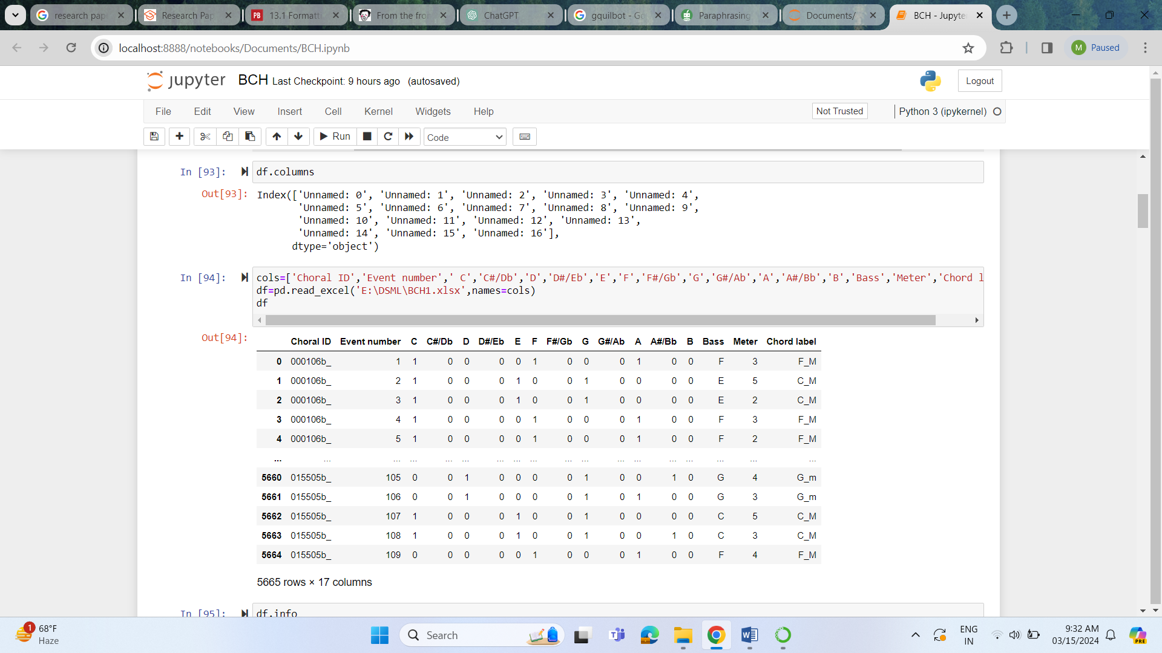

**Related:** Choral harmony refers to the combination of different musical pitches, tones, and voices in choral music to create a pleasing and cohesive sound. It involves the simultaneous singing of multiple melodies or vocal parts, such as soprano, alto, tenor, and bass, which blend together to form harmonious chords. Choral harmony requires careful attention to intonation, balance, and expression to achieve a unified and resonant sound. Composers and arrangers often manipulate choral harmony to evoke different emotions and convey the intended mood of the music. In Choral Music, "musical pitches" refer to specific frequencies represented by notes, "tones" describe the quality of vocal sound, and "voices" denote the individual vocal parts or sections within a choir. Together, these elements contribute to the overall richness and complexity of choral music. Bach chorales have been a popular corpus for previous work on automatic composition.

**Analysis:** Python libraries like as pandas, numpy, matplotlib, and seaborn are utilized in the project. In order to choose the most significant characteristics based on the requirements and comparative features, the data is first examined and cleaned to remove any zero values. Given that the data is formatted Scaling is accomplished by importing the MinMaxScaling technique from sklearn (a robust and adaptable Python machine learning program that can be used by both novices and seasoned professionals). According to the dataset seen, the pitches and meter are the input to predict the Chord Label outputs of the choral Harmony. As the data is scaled the Cross validation is a technique used in machine learning to evaluate the performance of a model on a limit data sample. The process entails dividing the data into several subsets, using one subset to train the model, and using the other subset to assess the model's performance. For Cross-Validation, the train_test_split method is accordingly employed. An algorithmic prediction method called the Neighbors Classifier is applied to assist in forecasting the system's output values. Furthermore, one of the key variables in determining the dataset's prediction rate is the accuracy score. The accuracy score on prediction is 0.7353563867325336. The relationship between the predicted and actual values is scored for accuracy. As predicted, they should therefore fall between 0.7 and 0.9. Regarding HypeTuning the parameters for the dataset's input-output algorithm decision-making relationship.

**Overview:** It has been seen that the prediction rate for the Pitches and Meter verses the output rated Chord Label values the brute’s algorithm has been taken to the Accuracy Score of the 73.535% after Analyzing the dataset. The accuracy and correctness of harmonies performed by a chorus are assessed using the choral harmony accuracy score. It evaluates the vocalists' ability to blend their tones, stay in tune, and keep the appropriate space between notes. With a high accuracy score, the choir is able to produce a rich and well-balanced sound by expertly and cohesively executing harmonies. On the other hand, a low accuracy score could indicate problems with sustaining a steady tone, synchronization between vocalists, or pitch errors. A choral harmony accuracy score of 73.535% suggests that the choir demonstrates a moderate level of proficiency in executing harmonies. While this score indicates that the choir generally performs well and achieves a cohesive sound, there is still room for improvement in certain areas. Possibly reaming 26.465% can be maintained on improving Pitch Accuracy, Timing issues, Tonal Balance, Expression and Dynamics, etc area.